Hosted by
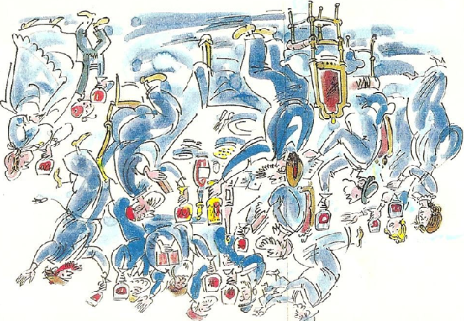

Passover

Let all who are hungry come and eat! Let all who are in need come and celebrate the Passover feast!

Haggadah
♦ Invitation
♦ Lighting the Candles
♦ Kadesh (Sanctification)
♦ Kiddish: Blessing of the wine
♦ First cup: “I will deliver you from the burden (tolerance) of the Egyptians.”
− Urchatz (wash hands): royal priesthood
− Karpas (parsley & salt water): slavery and tears
− Yachatz (breaking): Break the middle matzah & hide the afikomen (satisfaction)

− Maggid: Telling the story
− The Plagues: Blood, frogs, lice, flies, pestilence on livestock, boils, hail, locusts, darkness, slaying of the firstborn
♦ Second cup: “I will deliver you out of Egypt”
− Matzah
− Moror (bitter herbs → horseradish): bitterness of bondage
− Charosis (sweet apple mixture): mortar for bricks
♦ The Meal
♦ Tzafun (hidden or concealed): Finding the afikomen
♦ Third cup: “I will redeem you”
♦ Fourth cup: “I will bring you to Myself”
♦ Hallel: Praise the Lord!
Next year in Jerusalem!
L’Chaim!

