Passover at

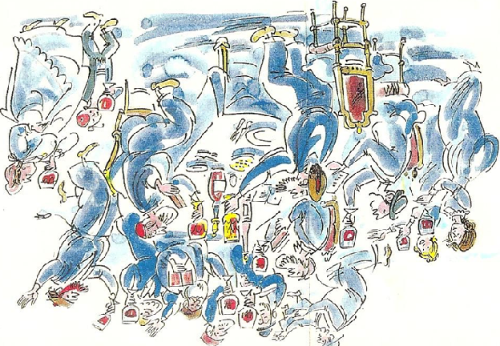

**Passover 2025**

Let all who are hungry come and eat! Let all who are in need come and celebrate the Passover feast!

***Haggadah***

¨ Invitation

¨ Lighting the Candles

¨ *Kadesh* (Sanctification)

¨ *Kiddish*: Blessing of the wine

¨ First cup: “I will deliver you from the burden (tolerance) of the Egyptians.”

- *Urchatz* (wash hands): royal priesthood

- *Karpas* (parsley & salt water): slavery and tears

- *Yachatz* (breaking): Break the middle matzah & hide the *afikomen* (satisfaction)

- *Maggid*: Telling the story

- The Plagues: Blood, frogs, lice, flies, pestilence on livestock, boils, hail, locusts, darkness, slaying of the firstborn

¨ Second cup: “I will deliver you out of Egypt”

- *Matzah*

- *Moror* (bitter herbs ® horseradish): bitterness of bondage

- *Charosis* (sweet apple mixture): mortar for bricks

¨ The Meal

¨ *Tzafun* (hidden or concealed): Finding the *afikomen*

¨ Third cup: “I will redeem you”

¨ Fourth cup: “I will bring you to Myself”

¨ *Hallel*: Praise the Lord!

Next year in Jerusalem!

L’Chaim!