Recipes

Beef Brisket: Miriam’s Melt-in-Your-Mouth Brisket
By Miriam Szokovski
Ingredients:
3 lb. first cut brisket
2 Tbsp paprika
2 Tbsp garlic powder
2 Tbsp dried chives (optional)
1 Tbsp salt (kosher, pink or sea salt)
2 large Spanish/sweet onions
½ cup balsamic vinegar
1/3 cup honey

Instructions:
- Preheat oven to 400 degrees.
- Slice onions in rounds. Place them in the bottom of baking dish.
- Combine the paprika, garlic powder, chives, and salt in a small bowl. Pat the spice rub all over both sides of the meat until it can hold no more.
- Place the meat on top of the onions and put in the oven at 400 degrees for 1 hour, uncovered.
- Take the pan out of the oven, reduce oven temp to 250 degrees. Mix the balsamic vinegar and honey with a fork to blend and then pour over the top of the brisket. Cover the baking dish tightly with foil and return to the 250-degree oven. Bake for another 4 hours, until the meat is fork tender. (Note: cooking time may vary depending on the size and thickness of your brisket, so make sure to use the fork test.)
- Approximately every hour, take the pan out and flip the brisket so both sides are equally moist. If this is not possible, make sure to turn the meat once when half way finished.
- Once done, refrigerate the meat until completely cold, preferably overnight.
Day of Seder:
- Remove the meat from the refrigerator. Skim off fat. Move meat to a cutting board and slice meat against the grain in thin slices.
- Place cut meat in clean baking pan (foil okay).
- Remove any remaining fat from the sauce/gravy.
- Remove onions and set aside to be reheated and served at the meal as topping for brisket.
- Pour gravy over brisket, cover tightly with foil.
- Just prior to the start of your Seder, preheat the oven to 250 degrees. Place the brisket in the oven to bake for an additional 2-3 hours.
- Serve the brisket with gravy, and onions warmed in side dish.
The brisket freezes well, if there is any left over.

Charosis (Charoset)
This is a basic recipe; there are a variety of recipes online.
Makes 10 servings
Ingredients:
2 Granny Smith apples, peeled and grated
½ cup ground walnuts or pecans (optional)
2 Tbsp Mogan David or Manischewitz wine (grape juice if you are not using wine)
2 tsp honey or sugar
1 tsp ground cinnamon

Mix and refrigerate until your evening begins.

Omi’s Chicken Broth and Matzah Ball Soup
Chicken broth:
If you have a good chicken broth recipe, use what is tried and true, but this is the one my Jewish mother-in-law taught me years ago and is known to be authentic “Jewish penicillin!”
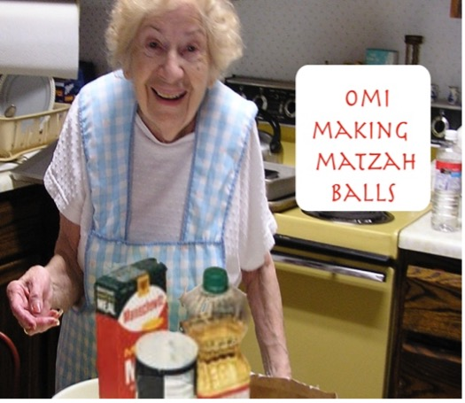
Ingredients:
1 whole chicken or several chicken pieces
6 carrots, cleaned and cut in half
5 stalks of celery, washed and cut in half
1 onion, peeled and cut in half
1 head cauliflower, cut in half
Add enough water to cover all ingredients
¼ cup fresh parsley
1 ½ tsp kosher salt (pink salt or sea salt if you prefer)
½ tsp ground black pepper
¼ tsp onion powder
¼ tsp poultry seasoning
¼ tsp thyme, dried, not ground

Instructions:
Throw all in a big stock pot, let boil on medium high, then after 45 min, turn down heat and cook for another hour or so.
Strain veggies and use for another recipe, if desired.
Shred chicken and use for another recipe, if desired.
Let broth cool in fridge overnight and then remove the fat. (Jewish people call the fat schmaltz and use it like butter on bread. (Not very good unless you grow up eating it. But our dog, Ruthie, loves it!)
Heat up the broth when ready to serve.
Note: If fuller bodied taste is needed, add 3 chicken bouillon cubes. Telma and Osem are good brands (found in the Kosher section of grocery stores). I found one on Amazon called Massel Chicken Stock Powder that is also good. (I used 1 Tbsp of the powder form.)
Matzah balls:
Follow directions on the Manischewitz Matzo Meal container, only add a few tablespoons seltzer water and a little more matzo meal to make the matzah balls “dance in the pan” (as Omi would say).
Note: Make sure to buy Matzo Meal and not Matzo Ball Mix.
To see a video of Christie making matzah balls, go to ruthsroad.org/guide.

Source: https://www.chabad.org/recipes/recipe_cdo/aid/2635033/jewish/Miriams-Melt-in-Your-Mouth-Rosh-Hashanah-Brisket.htm

