Leader’s Haggadah

The following is a sample of your personal Haggadah for leading the Seder with your guests. A copy in Word is available for download at ruthsroad.org/guide. Space is included for personal notes where you can add anything that the Lord highlighted to you in the tutorial (Chapter 5).

Introduce the Evening
Remember: This is a participation play, and we are rehearsing our identity change from slaves, to sons and daughters, to priests, and to brides. We will do this by eating symbolic foods, drinking wine to make us feel our freedom and joy in the Holy Spirit, singing songs and by telling the story of our redemption.
WELCOME TO THE FESTIVAL OF FREEDOM!
Personal notes:

Explanation of the Seder Plate
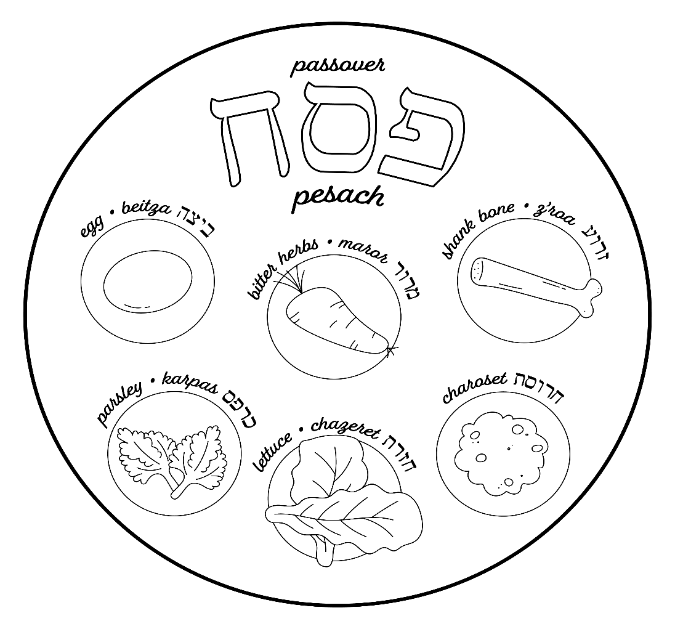
The items on the plate are described as follows:
- Parsley is a lowly herb dipped in saltwater to remember the tears of bondage.
- The lamb bone represents the Passover lamb.
- The egg (optional) represents the offering in the Temple.
- The horseradish (moror) represents the bitterness of slavery.
- The lettuce is an added bitter herb which we do not use.
- Charoset is a sweet apple mixture representing the mortar of the bricks they made.
- Matzah is the bread of affliction.

Invitation
“Open the door” to your Seder. Welcome your guests to your Seder table, emphasizing that as Gentiles, there has always been a place at the Seder table for them. These are God’s feasts (Leviticus 23:2) for both Jews and Gentiles who love Him.
For lo, the winter is past… The flowers appear on the earth; the time of singing has come. — Song of Solomon 2:11-12
Refer to the Heart Preparation letter (see Chapter 3) that you sent out a few weeks earlier, which encouraged them to search for leaven (chametz) before your evening together. This represents anything stale that has held us back, anything hidden that we want Him to bring to His light, so we can begin the process of walking through His appointments with a renewed heart.
Now stand, have everyone take a moment and reflect silently on anything from the past year that may have been a hindrance to their walk with the Lord.
Personal notes:

Light the Candles – Inviting His Presence
A woman has the honor of lighting candles before the Sabbath, and at the beginning of the Passover Seder, to bring light to the darkness that Eve brought to this world. As we light the candles, we say a prayer as we invite the presence of the Lord to be among us. (Slow down, focus on the Lord and pray from your heart.)
Baruch atah Adonai Eloheinu Melek ha’ olam, asher kid’shanu b’mitzvotav v’tzivanu, l’hadlik ner shel pesach
Blessed are you LORD our God, King of the Universe, Who has sanctified us with His commandments and commanded us to light our Passover candles.
Personal notes:

Kadesh (Sanctification)
This is a holy moment as we begin the evening recognizing that each one of us was chosen by God before the foundation of the world to be His. At this first step of the Seder, we enter a timeless place with all believers who came before us and all who will come after. We stand as individuals with our own unique story to tell, but also as a holy community, joined by His blood and His grace.
We are a chosen generation, a royal priesthood, a holy nation, His own special people, that we may proclaim the praises of Him who called us out of darkness into His marvelous light. — adapted from 1 Peter 2:9
Personal notes:

Kiddish – Prayer for the Wine
Remember: Wine is the symbol of freedom and the joy of the Holy Spirit. However, since we are no longer slaves, we will have someone else serve us. For this reason, have the person to your right pour the wine in your glass. We will not drink this first cup of redemption until the leader shares what it means. We all hold this first cup up as the leader prays for it. As the leader, hold up the cup from the main Seder plate and pray:
Blessed are You, Lord our God, King of the universe, Who has granted us life, sustained us with your blessings, and have brought us to this moment together.
Then, in Hebrew or in English, or in both, whatever you are comfortable with, say:
Baruch atah Adonai, Eloheinu Melech ha-olam, borei p’ree hagafen
Blessed are you, LORD our God, King of the universe, Who creates the fruit of the vine.

Introduction of the Four Cups
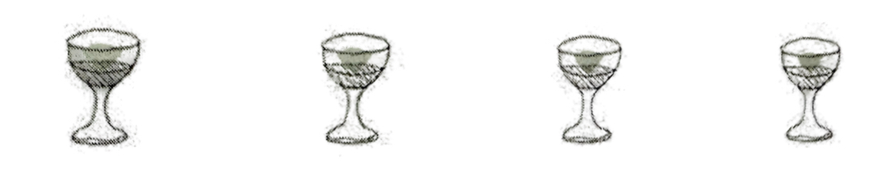
Read the four “I wills” from Exodus 6:6-7, emphasizing each “I WILL statement:
Therefore, say to the children of Israel: “I am the LORD; I will bring you out from under the burdens of the Egyptians, I will rescue you from their bondage, and I will redeem you with an outstretched arm and with great judgments. I will take you as My people, and I will be your God. Then you shall know that I am the LORD your God who brings you out from under the burdens of the Egyptians.”
Note: See the picture of the four cups available for download at ruthsroad.org/guide, which you can use to show your guests at this point.
This is true of our whole Christian walk. Not what we do but what He does!!!!
Cup 1 | “I will deliver you from the burden of the Egyptians”
Cup 2 | “I will rescue you from their bondage”
Cup 3 | “I will redeem you”
Cup 4 | “I will take you as My people and I will be your God”

Personal notes:

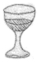
first cup
“I will deliver you from the burden of the Egyptians.” (Exodus 6:6)
Explanation of the First Cup:
Rabbi Abraham Twerski says that the word “burden” in this verse can suggest “tolerance,” meaning, “I will bring you out of your toleration of bondage.” They were slaves for 430 years with no desire for freedom. Bondage was a familiar spirit. God had to produce a supernatural cry in them to want to be free.
And the Lord said: “I have surely seen the oppression of My people who are in Egypt, and have heard their cry because of their taskmasters, for I know their sorrows. So I have come down to deliver them out of the hand of the Egyptians…” — Exodus 3:7-8
Ask God to make you hate anything you are tolerating, anything that is keeping you from loving Him or loving others.
Note: We like to play a worship song and spend time waiting on the Lord at this point.
Partake of this first cup together. (Be sure to enter in yourself as the leader.)
Personal notes:

Urchatz – Washing of Hands, Sanctifying the Priesthood
“And you shall be to Me a kingdom of priests and a holy nation.” These are the words which you shall speak to the children of Israel. — Exodus 19:6
For you are a holy people to the Lord your God; the Lord your God has chosen you to be a people for Himself, a special treasure above all the peoples on the face of the earth. — Deuteronomy 7:6
But you are a chosen generation, a royal priesthood, a holy nation, His own special people, that you may proclaim the praises of Him who called you out of darkness into His marvelous light. — 1 Peter 2:9
And has made us kings and priests to His God and Father, to Him be glory and dominion forever and ever. Amen. — Revelation 1:6
Remember: This is always a special time to connect with everyone at your table. Take a pitcher of water, a basin and a towel, and wash the hands of the person next to you, pray for them and then let them do the same for the person next to them. Remember, don’t be in a hurry. Ask God for a word of encouragement for them and bless them.
Personal notes:

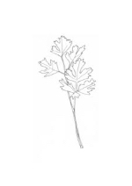
Karpas (Parsley)
Leader holds up parsley and prays:
Blessed are you, Lord our God, King of the universe, Who brings forth the fruit of the earth.
If you feel led to do the prayer in Hebrew:
Ba-ruch a-tah A-do-nai, E-lo-hey-nu Me-lech ha-o-lam, Bo-rey po-ri ha-a-da-mah
All partake by lifting the sprig of parsley from your Seder plate, dipping it in salt water and eating it together.
Personal notes:

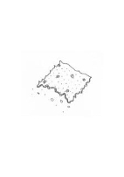
Yachatz – Breaking the Middle Matzah (Afikoman)
Remember: When you see that it is a picture of the Father, Son and Holy Spirit, and that the Son is broken, wrapped in a burial cloth and buried, and only those with a child-like spirit can find Him, you realize that Jesus is the Afikoman!
As the leader, take the 3 matzahs from inside the matzah bag (if you don't have a matzah bag use a large linen napkin or cloth). Now, break the middle matzah, take the larger piece, known as the afikoman, and wrap it in a white napkin.
If children are present, have them close their eyes while you hide it.
Personal notes:

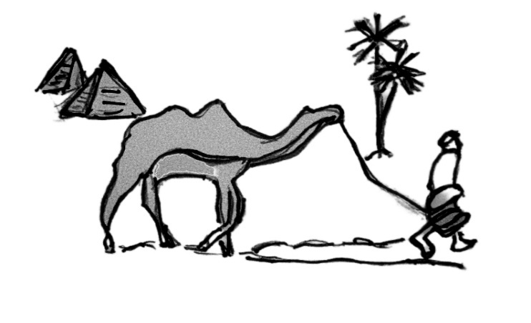
Maggid – Telling the Exodus Story
This is the time to tell the story of the Exodus and remember our own salvation story.
Suggestions:
- Have guests read portions of scripture that tell the Exodus story (Psalms 78 or 105 are good ones).
- Share how Jesus fulfilled Passover by using the chart in Appendix B. Hand out a copy of this chart to all your guests so they can follow along.
Remind your guests that this is their story too!
Personal notes:

The Plagues
For I will pass through the land of Egypt on that night and will strike all the firstborn in the land of Egypt, both man and beast; and against all the gods of Egypt I will execute judgment: I am the Lord. — Exodus 12:12
Remember: Everyone will recite the plagues together. As we name each one, make sure everyone has a full cup of wine. Then we take our little finger, dip it in the cup, take out a drop of wine and put it on our plate as we recite each plague. This is done based on the following Scripture:
Do not rejoice when your enemy falls, and do not let your heart be glad when he stumbles; lest the Lord see it, and it displease Him, and He turn away His wrath from him. — Proverbs 24:17-18
When our enemies are going through judgments and suffering, our joy (represented by the wine) is diminished.
Now recite the plagues in unison. (Note that the plagues will be printed on the mini-Haggadah at each guest’s place.)
Blood… Frogs… Fleas… Flies… Pestilence on livestock… Boils… Hail… Locusts… Darkness… Slaying of the Firstborn!
Personal notes:

Optional: Sing “Dayenu,” a traditional Passover song. You can find it on YouTube. See Appendix D for the lyrics.

second cup
“I will deliver you out of Egypt” (Exodus 6:6)
Fill each other’s cups again to be ready to drink it together when the time comes.
Share on second cup before you all partake.
Key points:
In the first Cup, God’s people were under the oppression of slavery with no desire for freedom. God supernaturally produced a cry in them for deliverance, and He answered. Then it was time for them to begin their journey out of Egypt to become fully His. See Exodus 12:5-11.
It is Yahweh that has an outstretched arm to bring them out, and it is the picture in Hebrew of a mighty warrior ready for battle, ready to execute impending judgment.
This was no time for lawlessness. The way out of Egypt was by obedience and faith in what God told them to do. His clear instructions are found in Exodus 12. The summarized plan: take a lamb, examine it four days, kill it at twilight, put blood on the doorposts, roast the lamb, eat the whole lamb with unleavened bread and bitter herbs. (Note that settled farmers boiled meat, nomads roasted it, pagans at it raw.)
For I will pass through the land of Egypt on that night and will strike all the firstborn in the land of Egypt, both man and beast; and against all the gods of Egypt I will execute judgment: I am the Lord. Now the blood shall be a sign for you on the houses where you are. And when I see the blood, I will pass over you; and the plague shall not be on you to destroy you when I strike the land of Egypt. — Exodus 12:12-13
Briefly explain the Threshold Covenant
(See my article “Threshold Covenant,” available at ruthsroad.org/guide.)
The meaning of the second cup is three-fold:
- The blood on the threshold and the doorposts was a sign of welcome for God to come into their dwellings and form a covenant family. They were now His sons and daughters and were part of His household. Likewise, the blood of Jesus applied to our lives when we believed that He died for us as our Passover lamb, made us sons and daughters in His family of believers. We are no longer orphans; we are no longer slaves.
- With the blood on the threshold, God “spread His wing” over the children of Israel and His courtship with His people began. He was taking them out of Egypt to be His bride, which is confirmed when God says to Israel:
When I passed by you again and looked upon you, indeed your time was the time of love; so I spread My wing over you… — Ezekiel 16:8
Thus says the Lord: “I remember you, the kindness of your youth, the love of your betrothal, when you went after Me in the wilderness.” — Jeremiah 2:2
To this day, the Song of Solomon is read by the Jews on Shabbat during Passover to commemorate the time where their marriage courtship with God began. Likewise, when we were born again, God’s ultimate identity for us was as His Bride.
- The blood on the doorposts, like the blood of Jesus over our lives, has the power to heal our physical bodies and makes us whole.
Now pray and partake of the second cup together.
As you pray and pause together remember the power of the blood and the price that was paid to save you from darkness and an evil world system. You are now a son or daughter of the Most High God and He has marriage on His mind. Another opportunity with this cup is to ask for physical healing that was also provided by the blood.
He also brought them out with silver and gold, and there was none feeble among His tribes. — Psalm 105:37
Remember to slow down, give the Holy Spirit time to interact with you. Don’t try to “manufacture” an encounter, but leave room for one.
Personal notes:

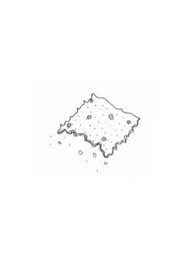
Matzah (Unleavened Bread)
You shall eat no leavened bread with it; seven days you shall eat unleavened bread with it, that is, the bread of affliction (for you came out of the land of Egypt in haste), that you may remember the day in which you came out of the land of Egypt all the days of your life. — Deuteronomy 16:3
Matzah is known as the bread of affliction, reminding us of the hardship of slavery.
The matzah is unleavened, striped and pierced, just as the prophet Isaiah describes the Messiah:
But He was wounded for our transgressions, He was bruised for our iniquities; the chastisement for our peace was upon Him, and by His stripes we are healed. —Isaiah 53:5
Leader prays for matzah and guests take a piece from their individual Seder plate and all eat together.
Baruch atah, Adonai Eloheinu, Melech haolam, haMotzi lechem min haaretz
Blessed are you, Lord our God, King of the universe, Who brings forth the fruit of the earth.
Personal notes:

Moror (Bitter Herbs)
Remembering the bitterness of bondage, we now take another piece of matzah with horseradish on it to remember the bitterness of our slavery. Encourage everyone to put a “healthy” amount of horseradish on a small piece of matzah and partake together!
Have tissues ready as people have their sinuses cleared out!!!
Personal notes:

Charosis (Sweet Apple Mixture)
This represents more bondage memories: the mortar of the bricks the children of Israel had to make in Egypt.
Make a sandwich with charosis and bitter herbs on matzah and eat it together.
Personal notes:

The Meal – Finally, You Get to Eat!!
This is a great time for discussion, thoughts, feelings, etc. (Remember, you aren’t done yet. It’s not just a meal together, but an extension of an experience as individuals and as a community.)
Personal notes:

Tzafun (“That which has been hidden”)
If kids are at your Seder, this is the time for them to find the hidden matzah called, afikoman. If no children are present, have someone else find it. Or, as the Leader, just bring it out of hiding.
Remember: Prior to the meal, this matzah was broken, wrapped in linen, and hidden away. Following the dinner, the matzah reappears.
To the messianic community of believers, this represents Jesus’ resurrection from the dead and all that His death, burial and resurrection accomplishes for us. He is still hidden to much of the Jewish community and our prayer is that they too would find Jesus, the Afikoman.
Hold on to the afikoman until after you share on the meaning of the third cup. Then, you will pass it around and have each person break off a piece and eat it with the third cup of redemption for a powerful experience.
Personal notes:

third cup – Part One: Baptism in the Red Sea
“I will redeem you” (Exodus 6:6)
In this Cup, we see God’s second challenge. Not only did He need to cause them to cry out for deliverance, He also had to transfer them from Pharaoh’s (Satan’s) kingdom to possess them as His own. God does everything legally and the children of Israel were Pharaoh’s legal possession.
For Christ also suffered once for sins, the just for the unjust, that He might bring us to God, being put to death in the flesh but made alive by the Spirit, by whom also He went and preached to the spirits in prison, who formerly were disobedient, when once the Divine longsuffering waited in the days of Noah, while the ark was being prepared, in which a few, that is, eight souls, were saved through water. There is also an antitype, which now saves us—baptism (not the removal of the filth of the flesh, but the answer of a good conscience toward God), through the resurrection of Jesus Christ, who has gone into heaven and is at the right hand of God, angels and authorities and powers having been made subject to Him. — 1 Peter 3:18-22
Explanation of the third cup:
Redeem means to “buy back.” In Genesis 47 the children of Israel sold themselves to Pharaoh for food. God had to buy them back and transfer ownership from Pharaoh’s possession to be His own. He does this through baptism in the Red Sea.
Just as in a marriage covenant, when one dies, the other is free to marry another. God does everything legally. When Pharaoh and his army were drowned in the sea, they were free to marry God and enter covenant with Him.
They could physically leave Egypt, but they still had to get the effects of Egypt off of them. We come into agreement with things in the world that keep us bound even after we are saved. The waters of baptism are where we bury all these “unholy attachments” and are raised up on dry land. God gives water baptism as the provision for us to “disarm principalities and powers” that we came into agreement with before we were saved. We leave those things in the waters of baptism just like the children of Israel could look back and see Pharaoh drowned in the sea. After baptism, Satan has no legal right to pull us back into those old habits and behaviors. Now we are free to make Jesus Lord of our lives.
Note: Some of your guests may choose to get baptized or re-baptized after hearing this teaching. At the least it is a good time to reappropriate what actually happened at our baptism. Baptism is powerful!
Personal notes:

Third Cup – Part Two: Communion and the Cup of Betrothal
Host or Hostess: Read “Ancient Jewish Wedding Ceremony” (see Appendix E).
In Luke 22:20, at the Last Supper (which is a Passover Seder), Jesus “took the cup after supper,” the third cup, and He turned it into a betrothal cup from a marriage betrothal. It is the first communion, or rather, the new marriage covenant that God promised was coming in Jeremiah 31.
Jesus starts talking wedding language saying, just like a Jewish Bridegroom, He will not drink the next cup (the cup of consummation), until He is with us in the Father’s kingdom (Matthew 26:29). This is referring to the second cup in a wedding ceremony, taken with His bride before entering the wedding chuppah to consummate the marriage.
Also, John 14:2 says, “In My Father’s house are many mansions… I go to prepare a place for you.” These are words that a Jewish Bridegroom would speak as he goes away after the betrothal ceremony to build a bridal chuppah or chamber attached to his father’s house.
Pour wine in each other’s cups and get ready to partake.
We play a worship song as our guests sit and think about how this is a cup of betrothal that Jesus is putting before them. Will they say “Yes” and then drink the cup?
He is their Bridegroom who paid the ultimate bride-price with His own blood. He had to pay the price for their sin so He could have a pure and spotless bride worthy of Him.
Hebrews 12:2 says, “…for the joy that was set before Him endured the cross…” We were the joy set before him! Wow! Let that reality sink into our hearts every time we take communion!!
Every Passover, and every time we take communion, we can lift our cup and say “yes” to Him again!
When the song ends, Partake of the cup together.
Note: This is where you can take the afikoman and the kiddish cup from the Seder plate and take communion together.
Personal notes:

Fourth Cup – The Cup of Consummation
“I will take you as My people, and I will be your God” (Exodus 6:7)
Remember: The fourth cup is our destination and it is full of revelation and meaning. Jesus did not take this cup with His disciples because it is reserved for that day in our future when the Father says the bridal chamber Jesus is preparing for us is finished and He comes to “abduct His Bride” for the wedding!
But I say to you, I will not drink of this fruit of the vine from now on until that day when I drink it new with you in My Father’s kingdom. — Matthew 26:29
Note: It is your choice whether to drink this fourth cup. We have refrained as Jesus did, to wait for our future consummation, and we have also partaken of it as a proclamation of what is to come. It’s up to you.
From slaves, to sons, to a kingdom of priests, to a bride. That sums up, in a nutshell, the pattern of the four cups of redemption!
Partake together after filling each other’s cups again (if you choose to do this).
Personal notes:

Hallel – Praise the Lord!!!
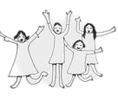
He is coming again: as a Jewish man, on a biblical holiday, for a beautiful bride, Jew and Gentile, one new man!
Hallelujah!
Next Year in Jerusalem!
(Proclaimed at the end of every Seder as a declaration of the Jewish yearning for that day in the future when the conquering King Messiah will come!)
Mazel Tov! Congratulations! You did it! You may have felt a bit lost or maybe awkward doing this for the first time, but you just took your friends and family on a memorable journey with the Living God and He is so pleased!!

Rabbi Abraham J. Twerski, From Bondage to Freedom (New York: Sharr Press, 1995), 67

