# Heart Preparation for Passover

By Christie Eisner

So let no one judge you in food or in drink, or regarding a festival or a new moon or sabbaths, which are a shadow of things to come, but the substance is of Christ. — Colossians 2:16-17 (NKJV)

The “substance” in all of the Leviticus 23 festivals is Jesus. They are prophetic pictures of Him and they are to be observed for the purpose of heart encounter. As we partake of the Passover together, we want more than a night of dead liturgy; more than mechanically going through the Passover Seder. Passover is a picture of our redemption in Jesus. It is the first of the Jewish festivals listed in Leviticus 23. It marks the beginning of the Jewish religious year during the Hebrew month of Aviv (Nisan). In Leviticus 23 it is called a “holy convocation,” a Hebrew word that means rehearsal. It is to be acted out or “rehearsed” every year so we can remember God’s great work of salvation in our lives. By looking back, we see His faithfulness in our lives in the past. By looking forward, we see the yet-to-be-revealed aspect of His love. And by looking at our hearts and lives in the light of our present circumstances, it allows us to feel His pleasure and ask for His help.

We want you to stay connected to what I refer to as an epic screenplay. God’s story of redemption is a beautiful love story: from the beginning of Genesis, where He lost His intimate relationship with mankind, to Revelation,where we see a Bride coming down prepared for her husband. The entire Bible is His divine romance with His people. The Leviticus 23 feasts are His appointments (*moedim*), the plan that He has established, to win back His Bride and restore our planet earth to paradise. God’s plan starts in the Garden of Eden where the enemy stole His intimate partners and defiled the perfect earth where He dwelt with them. Immediately, the Father put in motion the storyline of how He was going to redeem both. The “Divine Romance,” as I call it, goes from bride stolen and garden lost to bride redeemed and garden restored. Genesis through Revelation is an epic love story of how God sent a Messiah-Redeemer to walk out the four steps of redemption to accomplish this. These four steps can be summed up in the four cups we will partake of at the Passover Seder, to remind us that though we are freed from bondage and healed spirit, soul and body as sons and daughters in our Father’s household, though we now have full access by His blood to go into His presence as priests, our ultimate identity is His intimate, bridal partner, bringing *tikun olam* (restoration of all things) as His co-redeeming partner in love!

Just as the other festivals listed in Leviticus 23, Passover is an “appointed time,” a “*moed*,” an appointment on God’s holy calendar that, although He fulfilled the spring feasts at His first coming, He desires to meet with us every year on these appointed times so we can enter into our own personal story of salvation and deliverance. The feasts are the “blueprint” of His plan of redemption. The “former rain” festivals like Passover are in the spring and refer to His first coming. The “latter rain” festivals are in the fall, referring to His second coming.

He will come to us like the rain, like the latter and former rain to the earth. — Hosea 6:3

During our Passover celebration together, we are to remember and experience our personal testimony of how God delivered us out of the darkness of our unredeemed lives in the world (Egypt), delivered us from the bondage of a cruel taskmaster (Satan/Pharaoh), brought us through death and burial in our water baptism (the Red Sea), and raised us to new life into our intimate relationship with Him. This is to be experienced! You are entering into a picture of remembering your own salvation journey by being a participant in this night, as an individual and as a community, as you partake of wine and various ritual foods etc. Passover is referred to as the festival of freedom.

During the Seder (order, or order of service), you will taste foods that represent different elements in the Exodus story. Central to the evening we will be drinking four cups (or sips) of wine that represent the four parts of our redemption. We use wine because it is part of experiencing our freedom, but if you prefer to use grape juice, that is totally acceptable (although a Jewish Rabbi said that it is very difficult to feel free after four cups of grape juice!).

Jewish people use wine at festivals, Sabbaths, and weddings, because wine represents the joy of the Holy Spirit. Orthodox Jews believe that a spiritual person can rejoice and celebrate a festival with food and drink without it diminishing his spirituality. To the Greek way of thinking, things are understood with our minds, intellectually. Hebrew thought, on the other hand, still satisfies the intellect, but believes that true learning and understanding begins in the heart and senses. The things in our hearts connect to our remembrance, since they have been experienced. As Jesus said to the religious leaders of His day:

You search the scriptures, [intellectually/religiously] for in them you think you have eternal life; and these are they which testify of Me. But you are not willing to come to Me [in intimate encounter] that you may have life. — John 5:39-40

John confirmed that getting to know God is experiential:

That which was from the beginning, which we have heard, which we have seen with our eyes, which we have looked upon, and our hands have handled, concerning the Word of life. — 1 John 1:1

God wants us to engage our hearts, minds, souls, emotions and senses to encounter Him. When Jewish children begin to study *Torah*, the teacher puts honey on their tongue to remind them that tasting the Word is sweet. The biblical holidays are to be experienced and observed by communal participation.

The first thing a Jewish family does to prepare for Passover is to clean their house from all leaven. Leaven (or *chametz*) represents sin and slavery, so that religious Jews spend days before Passover cleaning their houses to rid them of all leaven, even down to any crumbs being found. In Exodus 12, the children of Israel were commanded to eat unleavened bread (*matzah*) for one week for the Feast of Unleavened Bread. They were to leave Egypt in haste, so they were to mix the flour with water, roll it flat, and immediately put it in the oven before it could rise. *Chametz* (or leaven) is dough that is left to sit around and rise before it is baked. *Chametz* represents anything old or stale—any ruts or dead routine that we have allowed to sit around and fester. Getting rid of it is a symbol of freshness and new life. Begin asking God to cleanse your heart of any “leaven” or uncleanness left hidden in your life. Ask Him to shine His light on any areas that need to be swept clean, and then ask for His forgiveness.

Sometimes our sin is so familiar to us that we lose the desire to get rid of it. Jesus asked the man at the pool of Bethesda, who had been sick with an infirmity for 38 years, “Do you want to be made well?” (John 5:6)

We must hate our bondage; God provides the plan. We must cry out; God provides the cry. We must apply the blood; God provides the blood. We must gather our household and walk out; God leads the way. But we cannot be passive in our quest for freedom!

Out of fear and lack of taking responsibility for our freedom, we can remain slaves!

The Exodus is an inner voyage as well as an outer experience. Being free comes with responsibility. Remaining a slave to our “hardship in Egypt” can make us passive, so that we live with a victim mentality. We may not have chosen our past bondage, but if we are offered a way out and don’t take it, if we don’t do our part, then we are choosing to remain slaves. We can end up blaming Egypt and Pharaoh forever and never get free. We can also blame God for allowing Egypt in the first place and deny His partnership to journey out.

We don’t walk out alone. We walk out together. We are responsible for each other to make sure as a community that we keep walking toward the freedom offered to us that comes from knowing and loving Him.

We look forward to “rehearsing” our redemption with you at our Passover Seder!

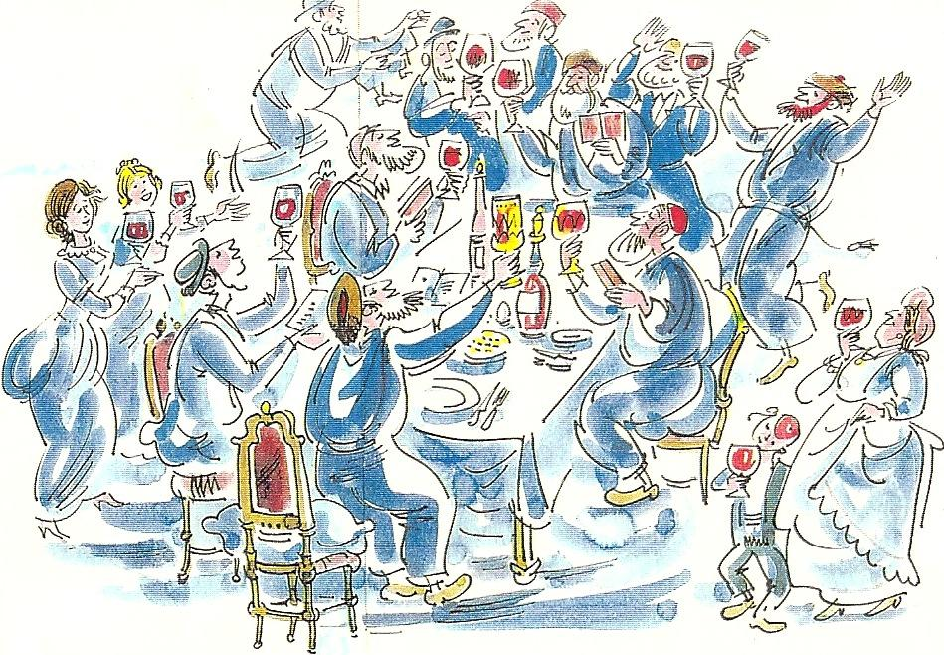

L’Chaim! (To Life!)